**Objectives**

* Understanding need for isolation in testing
* Understanding the concept of mocking
* Using Jest for unit testing and mocking

In this hands-on lab, you will learn how to:

* Unit test modules in isolation
* Creating and configuring mocks and spies

## **Prerequisites**

The following is required to complete this hands-on lab:

* Node.js
* NPM
* Visual Studio Code

## **Notes**

Estimated time to complete this lab: **60 minutes.**

As an intern at OpenAI you are assigned the task of creating and testing a React application which will fetch and display a list of repository names for a given user.

1. Create a new React application using *create-react-app* tool and name it as “gitclientapp”.
2. Open the application using VS Code
3. Go to terminal in VS Code and install the support for “axios” react library to make calls to the GitHub API.

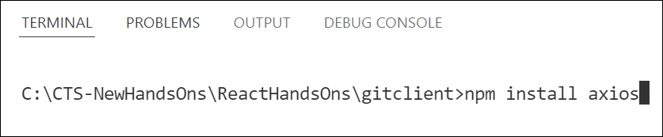

Figure 2: Install axios library

1. Create a new file with the name as **GitClient.js** in **src folder** of the application
2. Add the following code to create a class named **GitClient** which will make calls to the *api.github.com* to fetch the repositories as follows.

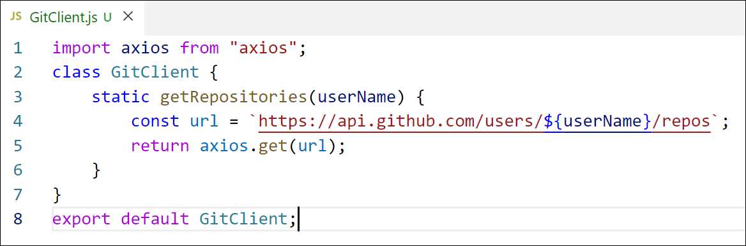

Figure 3: GitClient module

1. Modify the App component to use the declared module to fetch and display the repositories data as follows.

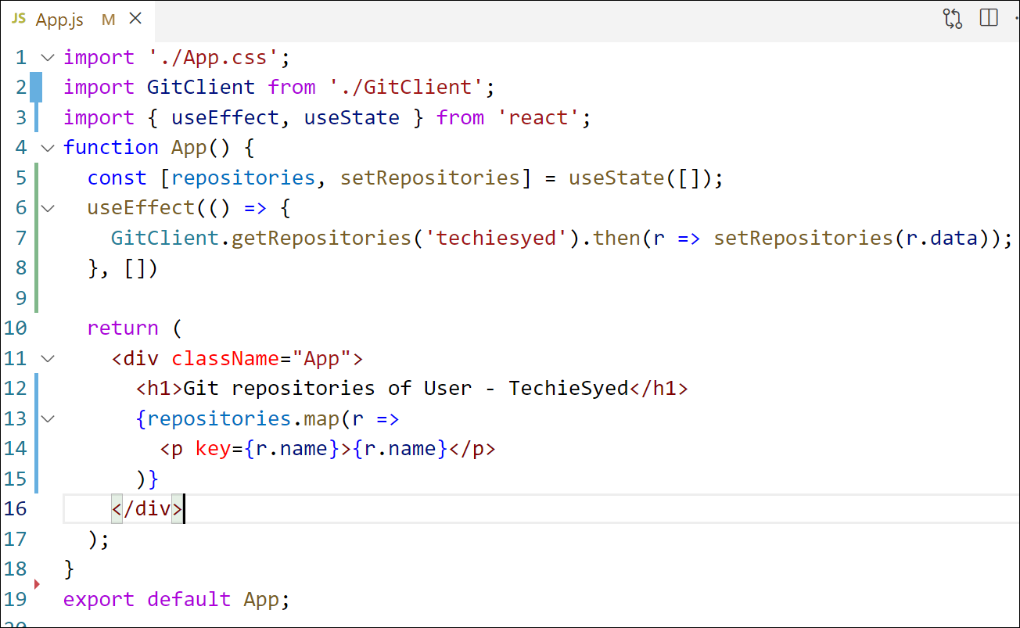

Figure 4: App Component

1. Build and Run the application using *npm start* command. The output should look similar to below.

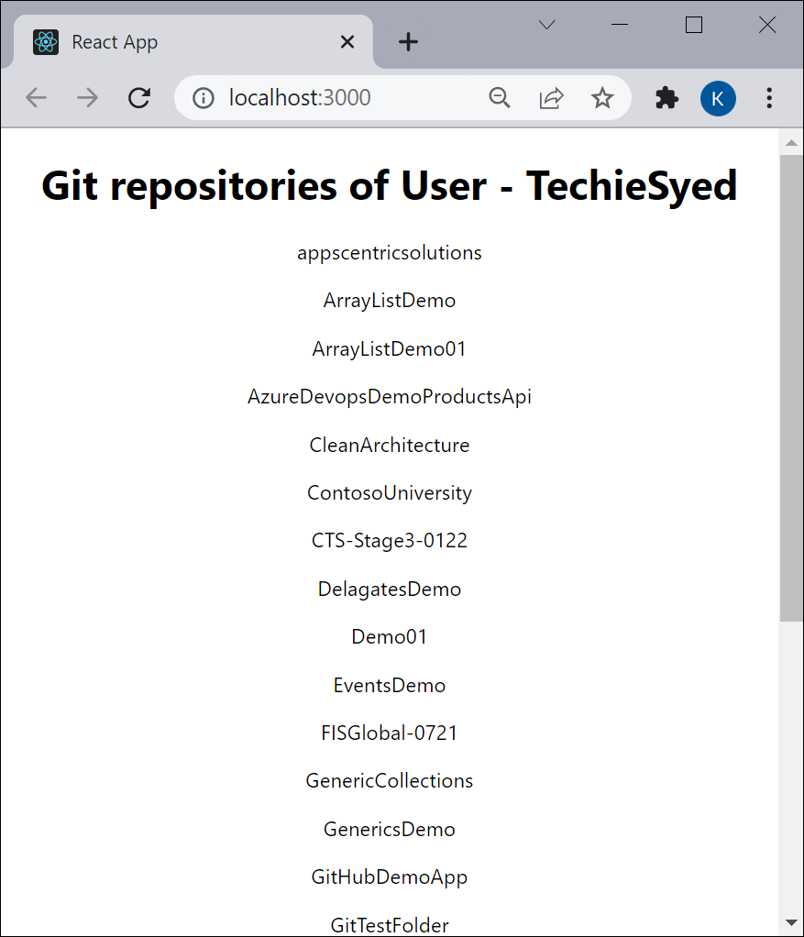

Figure 5: Application Output

1. Create a new unit test file named as **GitClient.test.js** to unit test the newly created module.
2. Import **axios** and **GitClient** into the unit test file.
3. Describe the test name as “Git Client Tests”
4. Create a unit test using the **test()** and give the test name as “should return repository names for techiesyed”
5. Mock the axios object to return the dummy data
6. Invoke the **getRepositories()** method of **GitClient** and see it’s returning the mocked data instead of making an actual call to *api.github.com*
7. Run tests using *npm test* command.

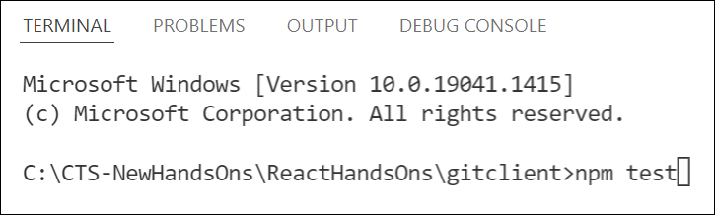

Figure 6: Run tests